13.86: Energy conservation during downward swing:
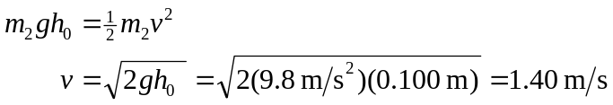

Momentum conservation during collision:

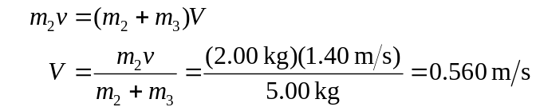

Energy conservation during upward swing:

